

DSP-ca#2

Filter Design and Analysis



Ordibehesht 99

sahand khoshdel

810196607

TABLE OF CONTENTS

Introdution 2

problem 1 3

problem 2 8

# Introduction

The purpose of this computer assignment is to design low-pass and high-pass filters in order to reduce the noise effect in the sound file given in the instructions

First, we designed the band-stop filter which filters the noise with the central frequency = 3142 Hz. Then we designed low=pass and high-pass filters to eliminate noise effects during slow and high oscillations.

# Problem 1:

### Part a)

The Fourier transform and the Shifted Fourier Transform of the noise sound are Shown in Figure 1-1,1-2

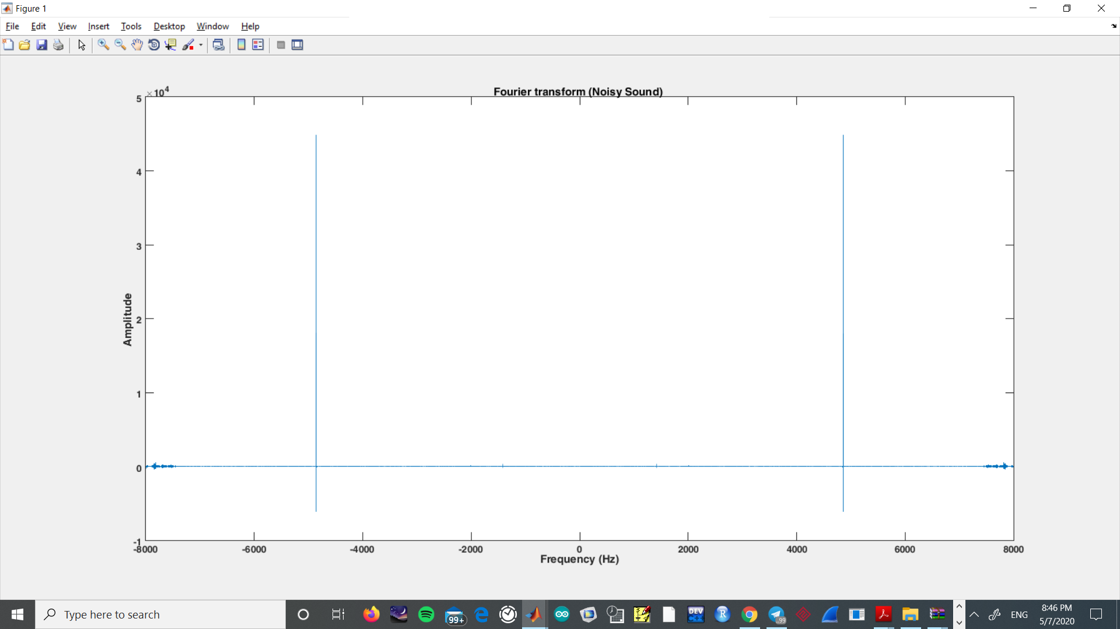

#### Figure 1-1

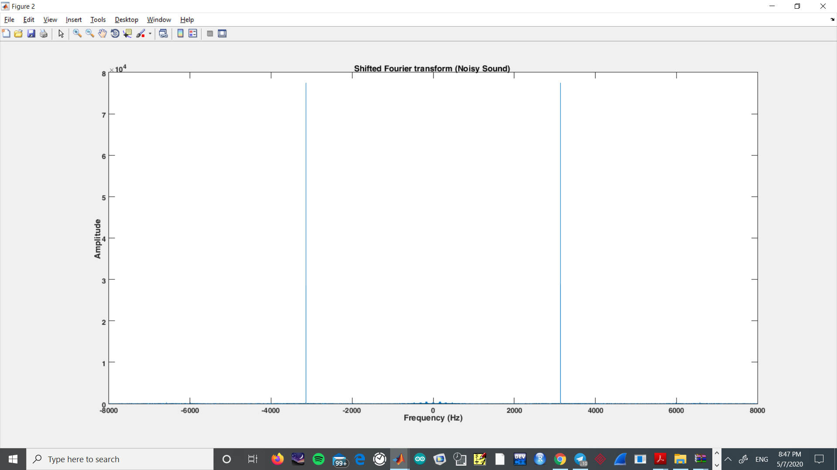

#### Figure 1-2

## Filter Design:

The noise reaches its peak at about F = 3142 Hz (Figure 1_3) (Shifted FFT in a larger scale near the peak)

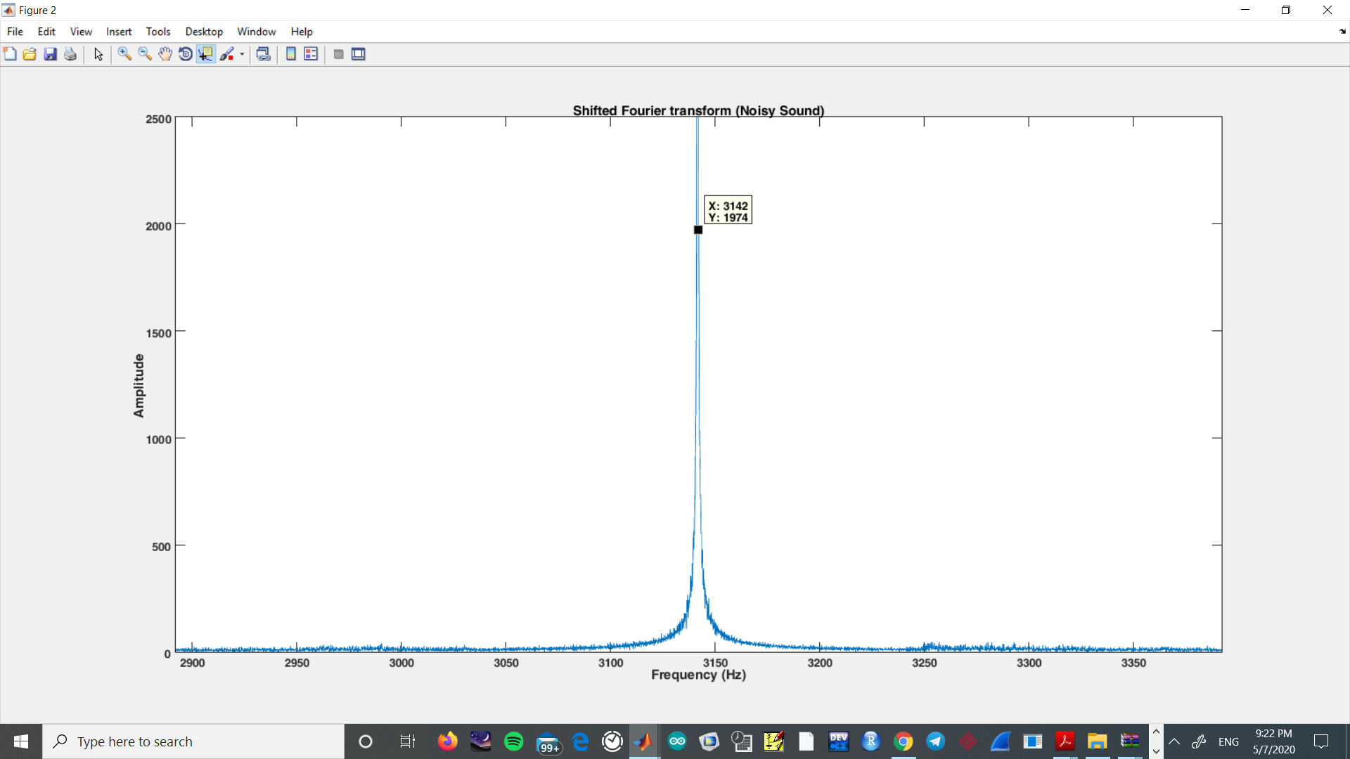

#### Figure 1-3

As we are to design a low order (not very sharp) filter, so we should consider a pretty wide range for the stop range in the “Band-stop Filter” that we’re designing. A range about 300 Hz would be proper.

Stop range start and end: [2842-3442(Hz)]

Pass range start and end: [2142-4142(Hz)]

### Amplitude and Phase Diagram of Band-Stop Filter :

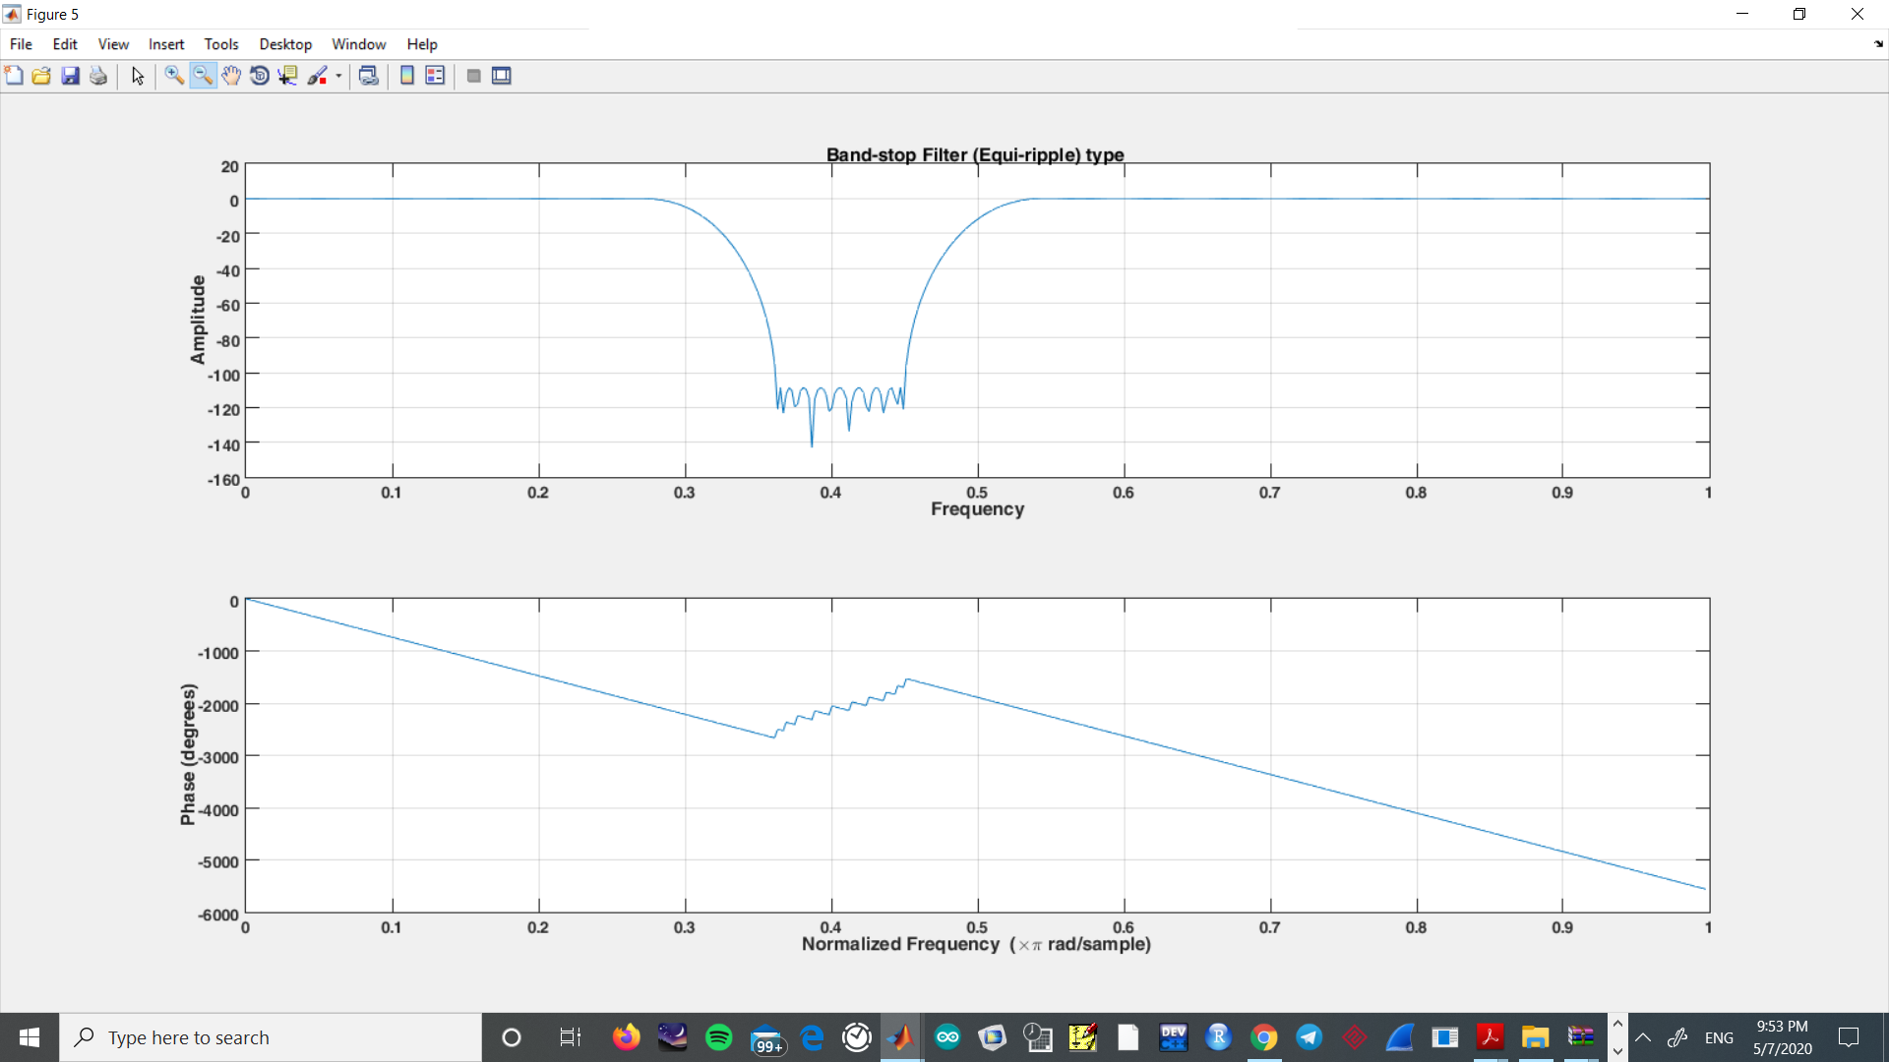

#### Figure 1-4

### Band-stop filter saved as coefficient (Numerator):

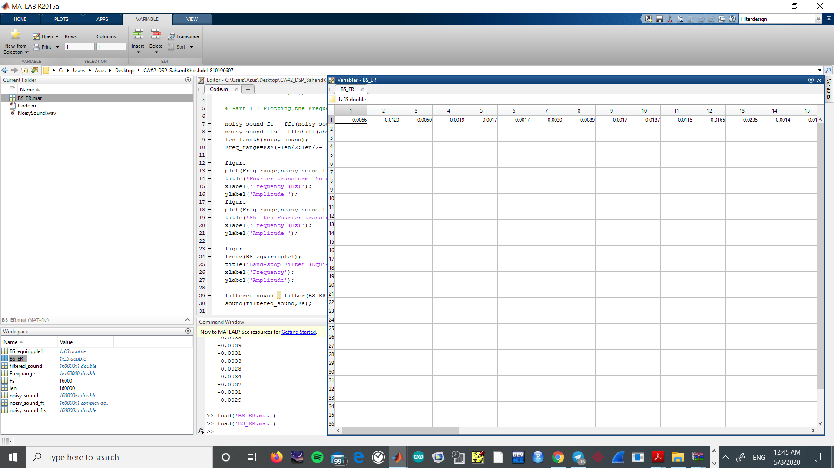

#### Figure 1-5

### Signal after using the band-pass filter(Normalized scale) :

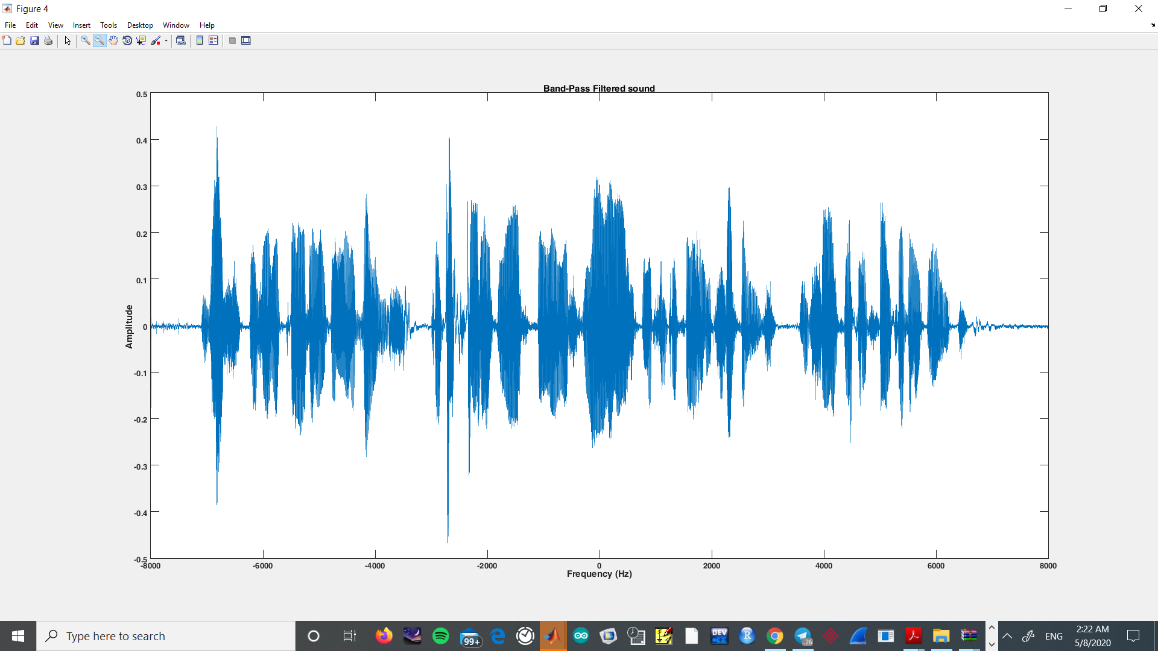

#### Figure 1-6

## Part D: Designing Low-pass Filter:

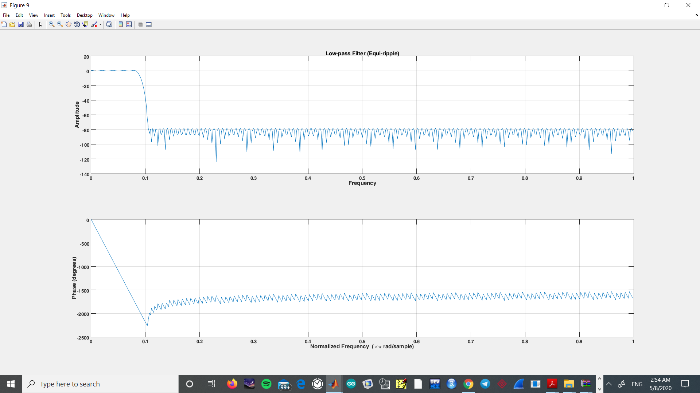

#### Figure 1-7

## Signal before applying filter: As we could guess, the signal experiences higher level of attenuation at higher frequencies

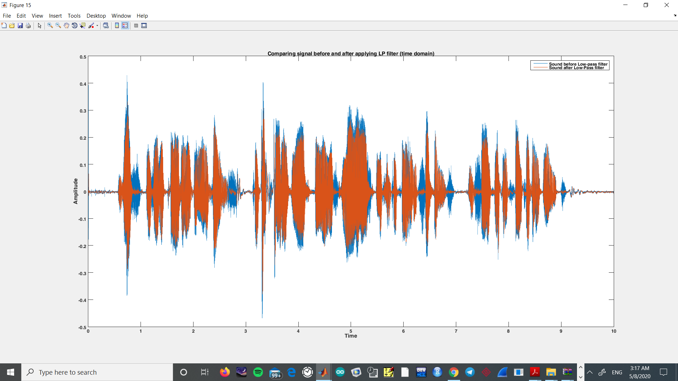

#### Figure 1-8

## Frequency response of signal after applying LPF:

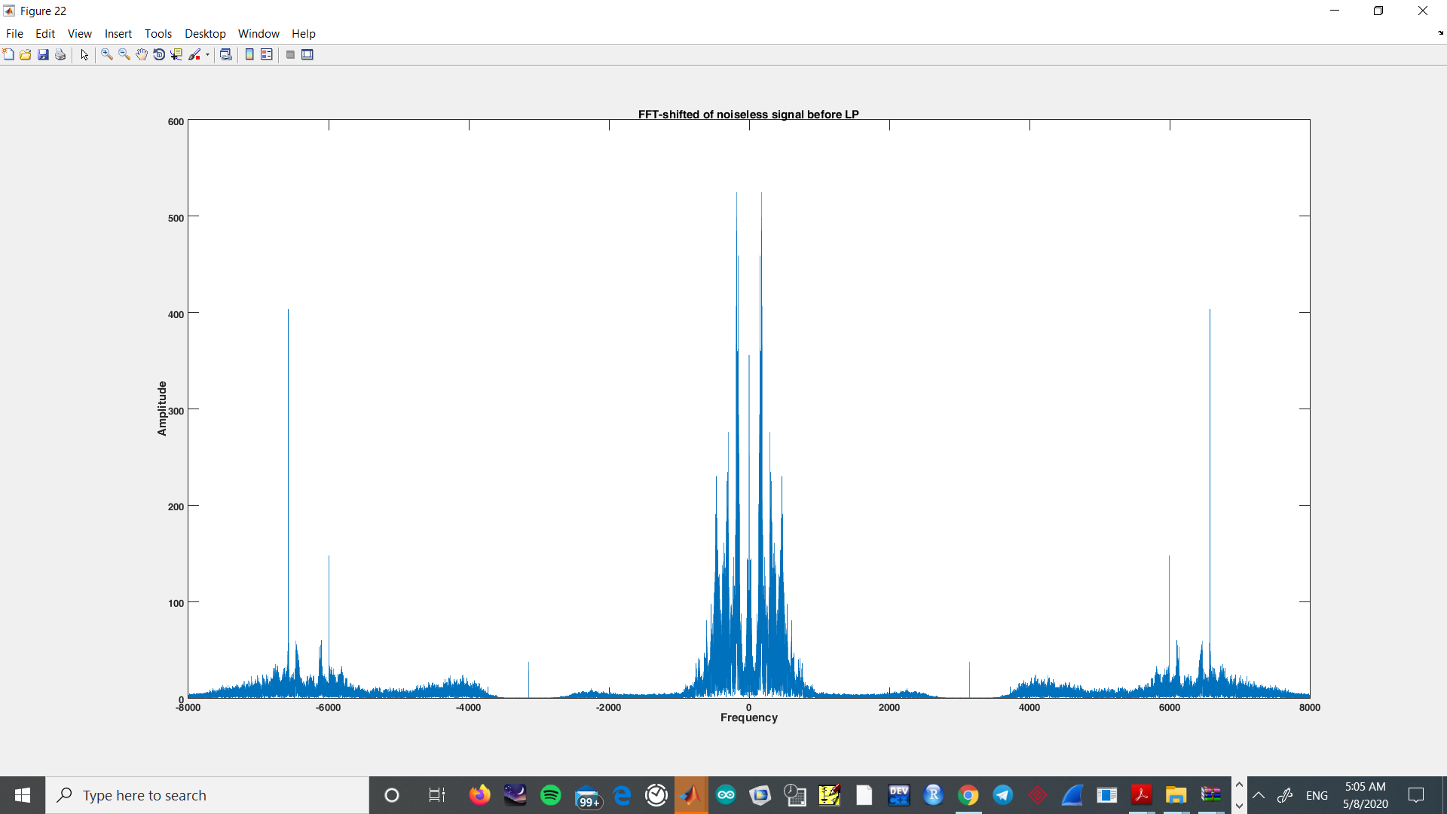

#### Figure 1-9

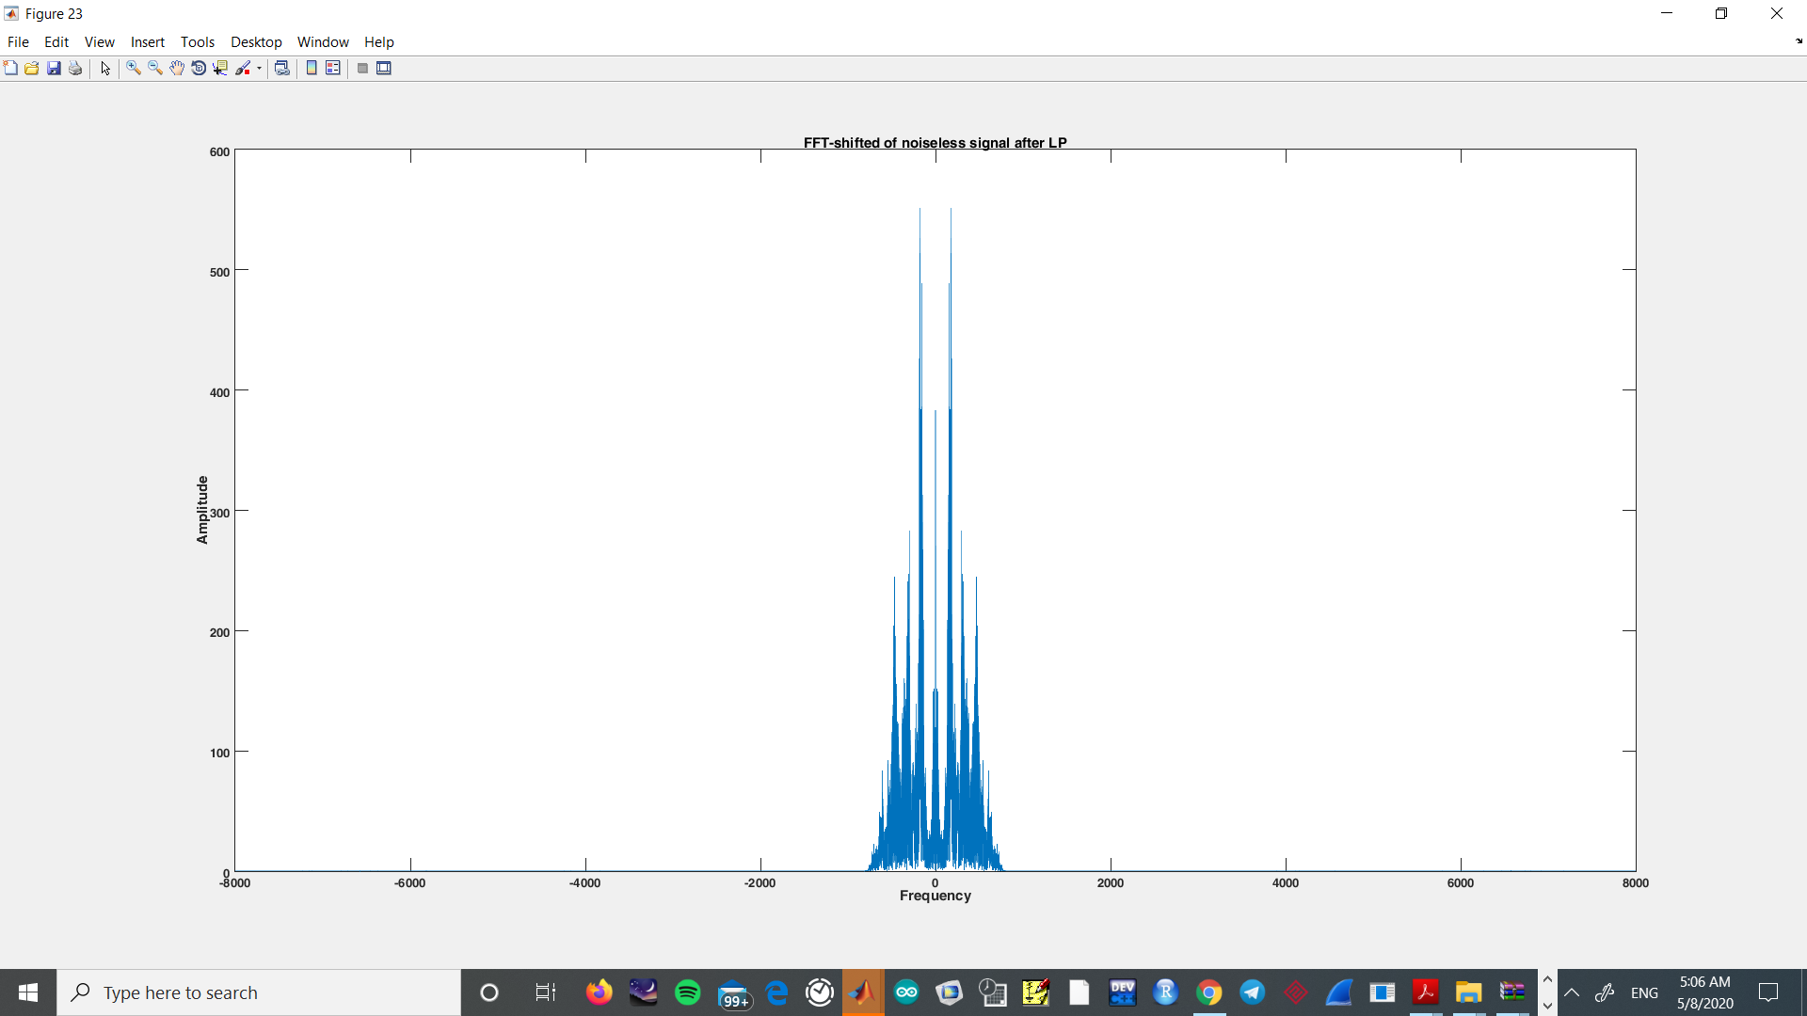

#### Figure 1-10

We Observe that after applying the Low-pass filter, higher frequencies are filtered

### Part E)

### High-pass Butterworth Filter:

### Magnitude-Phase Properties:

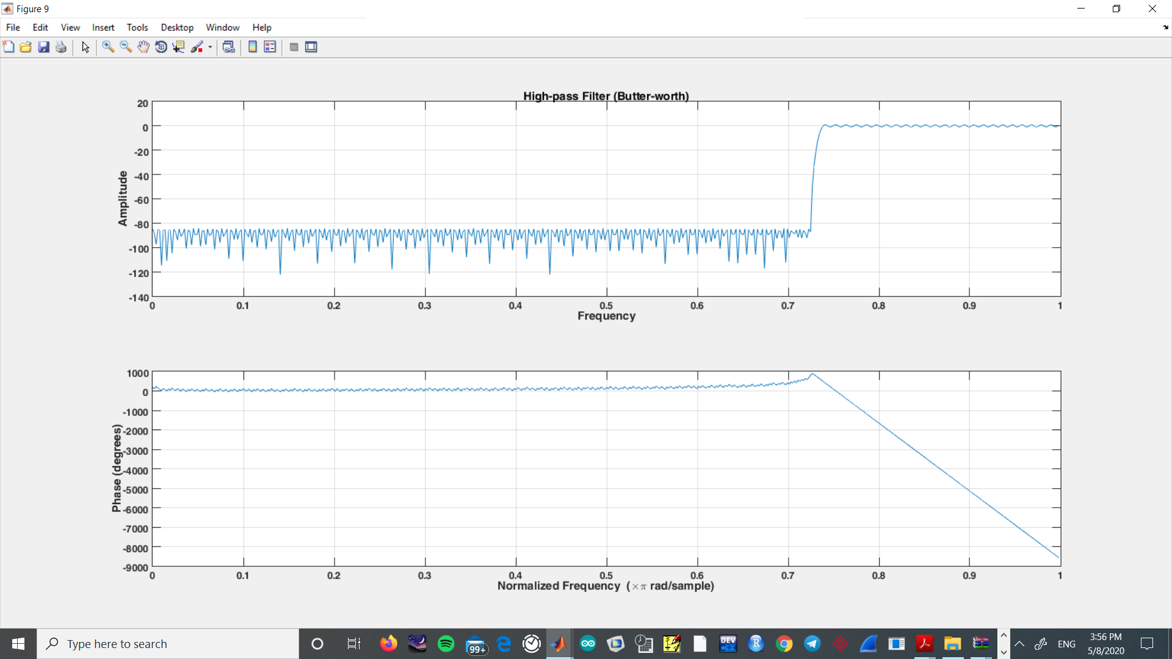

#### Figure 1-11

### Time-Domain comparison:

Faster oscillations are represented as higher frequencies that are filtered by the high-pass butterworth filter we designed

Assuming the LP filter and HP filter work separately and the high-pass filter isn’t implemented after the low-pass one:

### Time-Domain comparison:

Faster oscillations are represented as higher frequencies that are filtered by the high-pass butterworth filter we designed Assuming the LP filter and HP filter work separately and the high-pass filter isn’t implemented after the low-pass one:

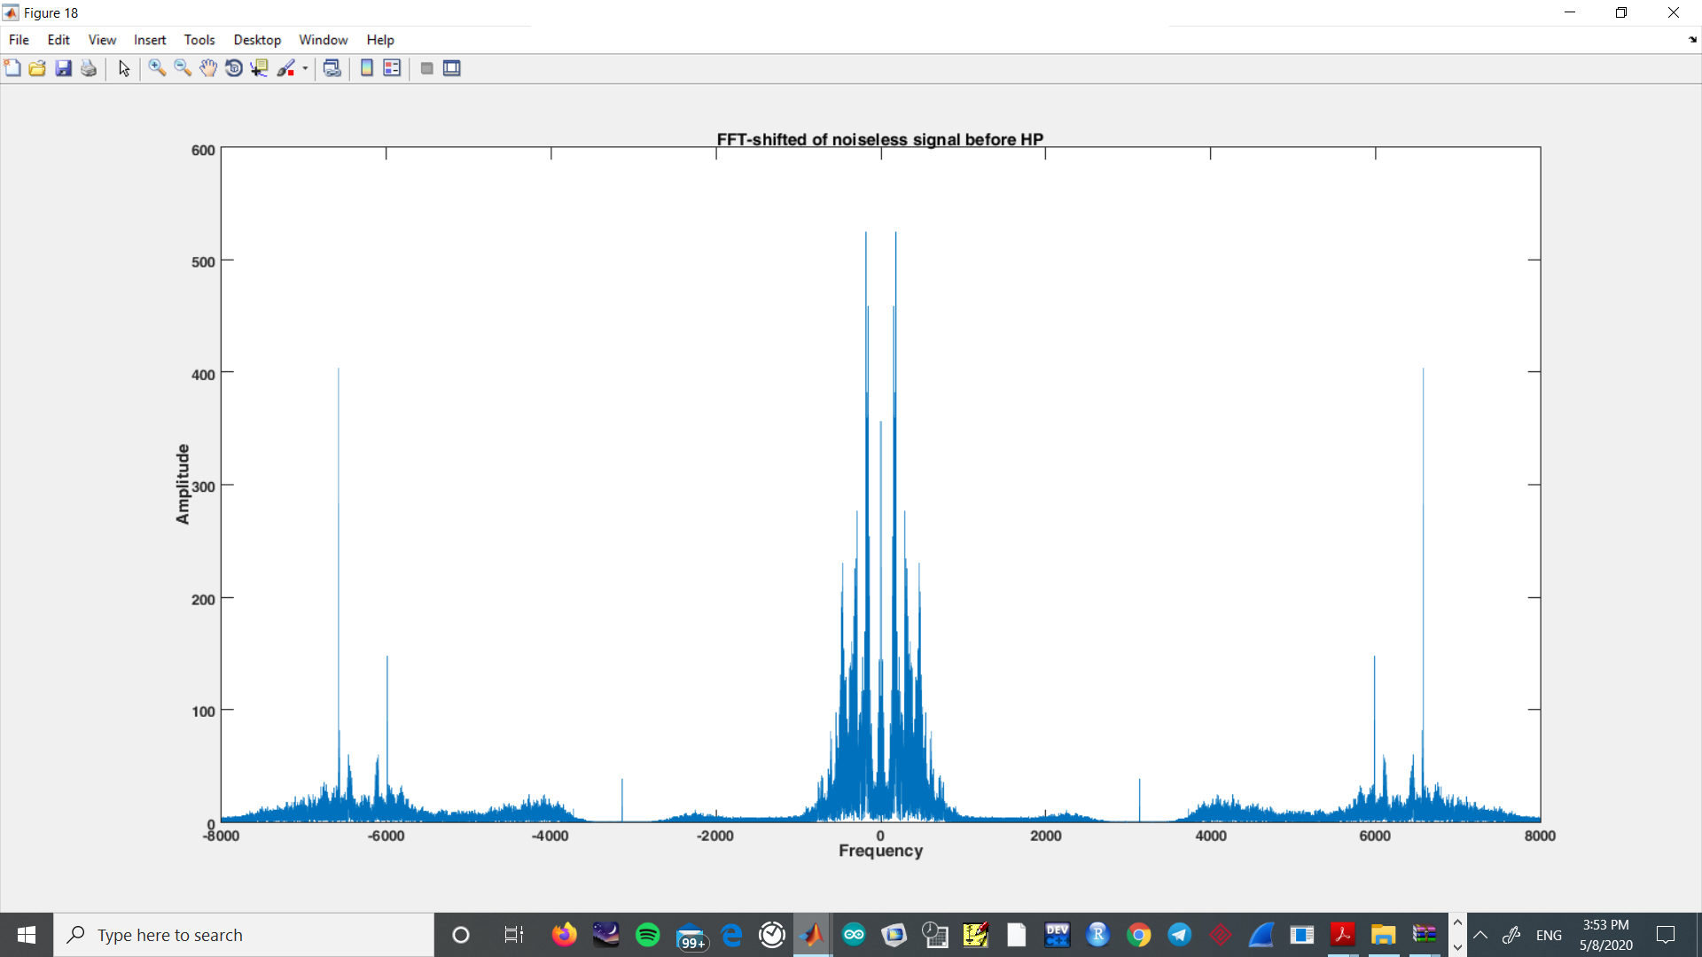

#### Figure 1-12

As we can observe the higher frequencies are passed and the lower frequencies are filtered:

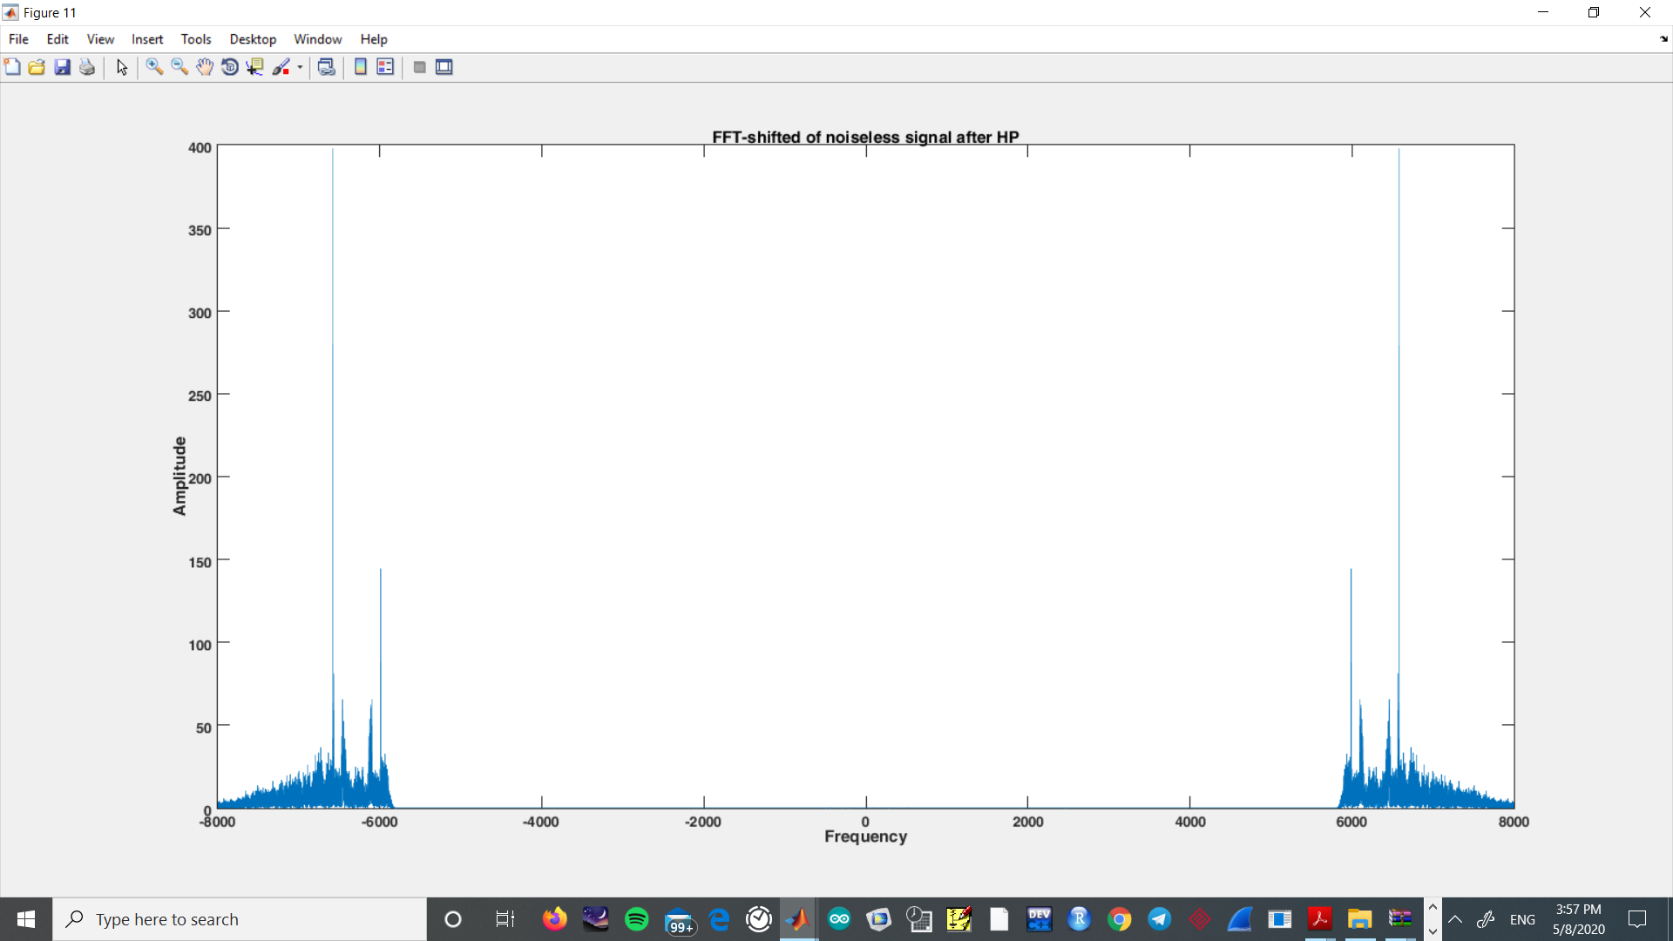

#### Figure 1-13

# Problem 2:

### Magnitude-Phase Properties:

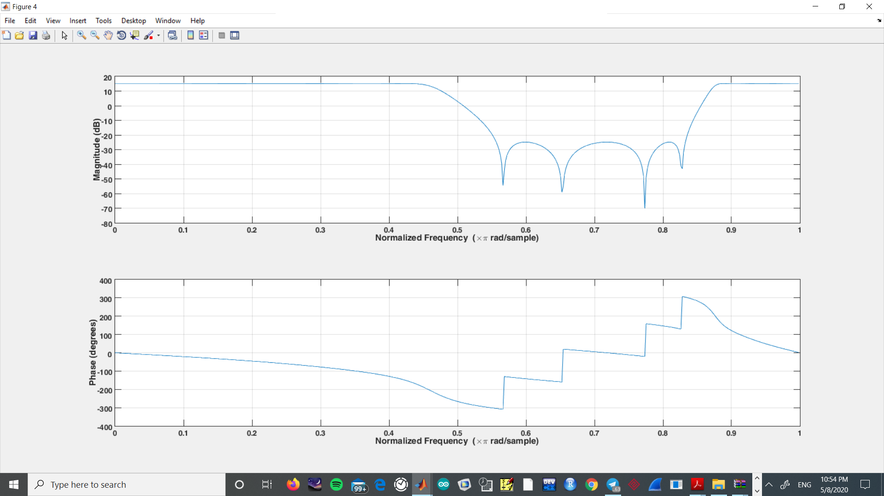

#### Figure 2-1

### Group and phase delay:

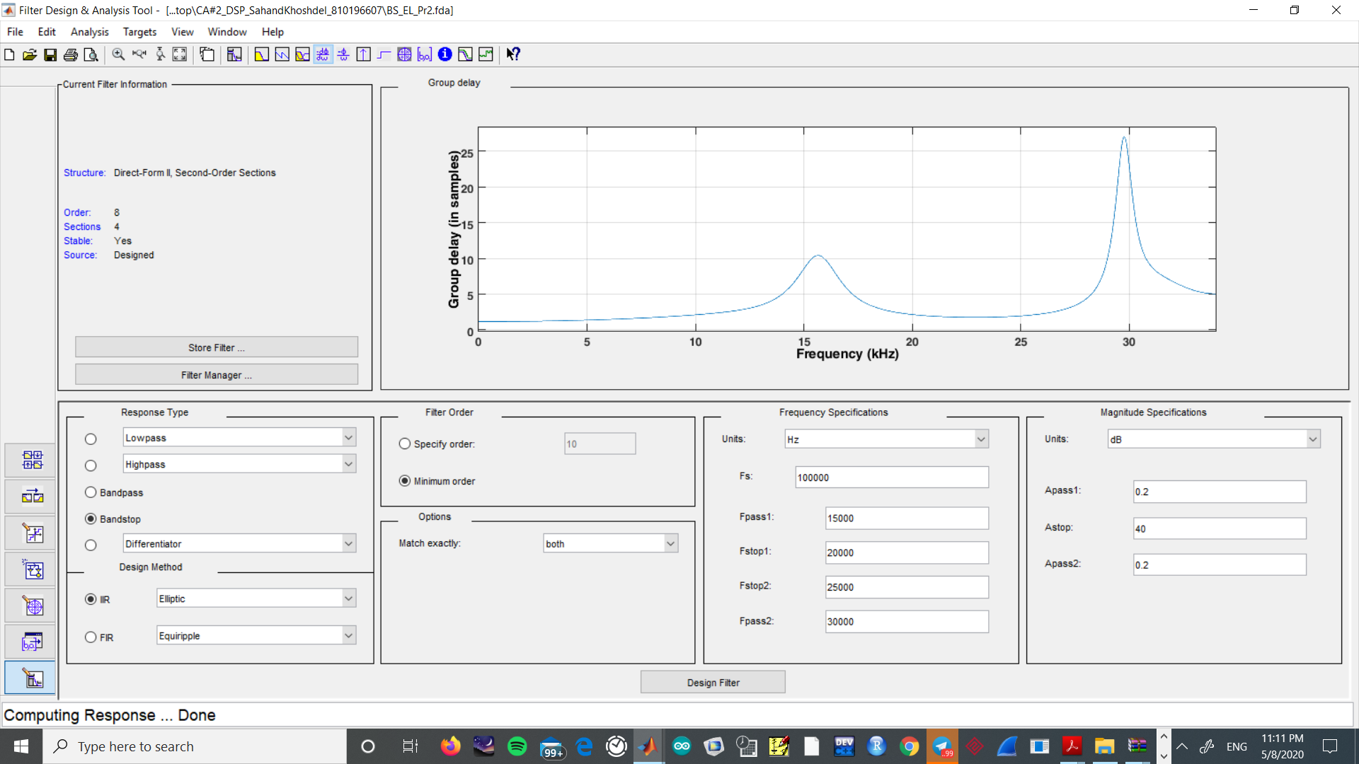

#### Figure 2-2

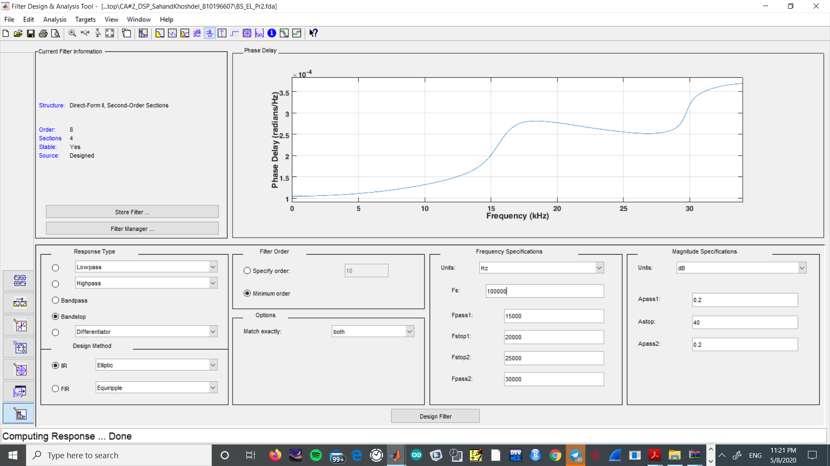

#### Figure 2-3

### Zero-pole plot :

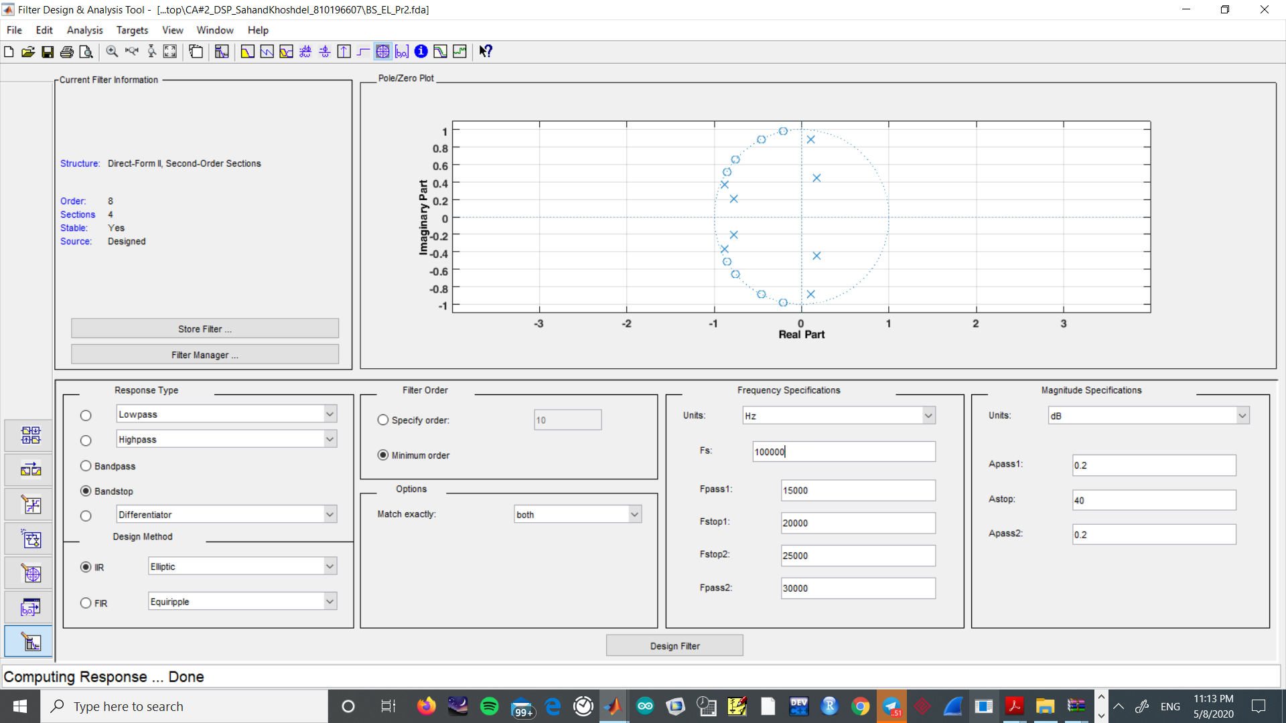

#### Figure 2-4

By observing the zero-pole plot we see all zeros and poles are inside the unit circle which indicates the filter is a minimum-phase filter (transfer function). So we will have the least group delay possible.

Group delay diagram represents the number of symbols of that particular frequency in which the input is changed (output is different)